Application for Tuition Scholarship
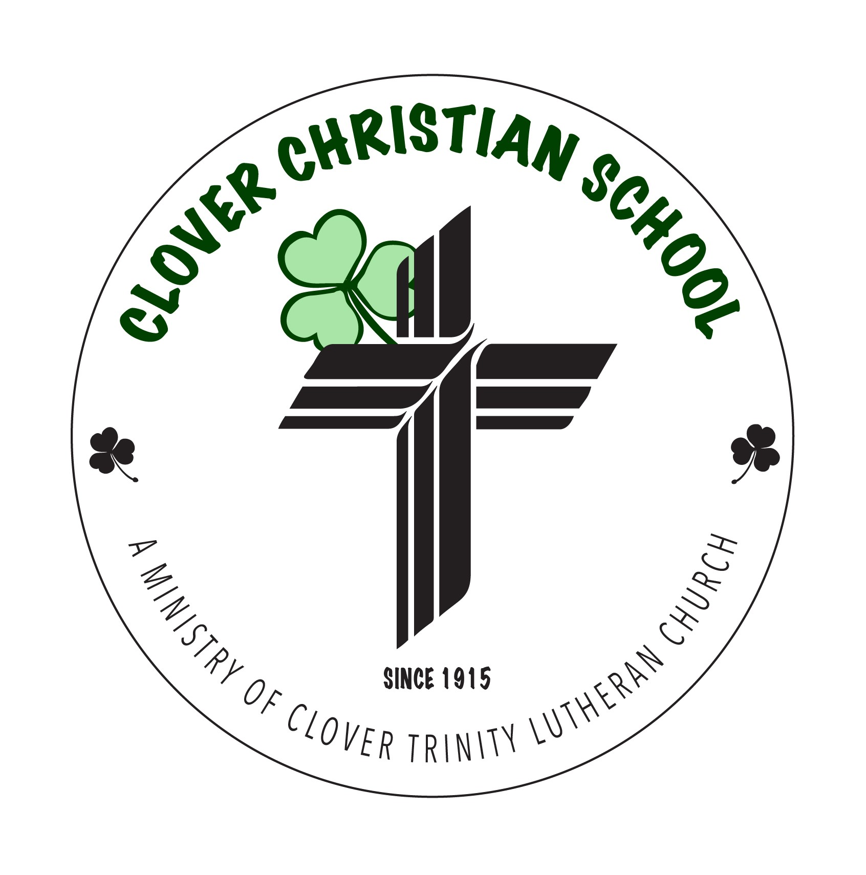
2020-2021

Fill out this form completely and return it to the school office. On the basis of the analysis of this application and in light of special needs (as indicated below), the Scholarship Committee will make a determination for tuition scholarship. Priority consideration will be given to applications that are received within 5 days.
GENERAL INFORMATION | DATE:
Parent/Guardian Names:
As of today, are you married? [ ] No (single, widowed, divorced)  [ ] Yes  [ ] Yes, but separated from spouse | Number of children enrolled at CCS last year:  -----------
LIST BELOW CHILDREN ATTENDING CLOVER CHRISTIAN SCHOOL | List Grade in 2020-2021
1.
2.
3.
4.
LIST BELOW CHILDREN not ATTENDING CLOVER CHRISTIAN SCHOOL | List Grade in 2020-2021
1.
2.
3.
INCOME
Adjusted Gross Income (Federal Tax form 1040 or 1040A) for the year 2019:
Current Monthly: Net take home income currently earned form work.
Father: __________________/mo. AFDC or ADC_____________/mo.
Social Security: ____________/mo.
Mother: ________________/mo. All child support: __________/mo.
Other taxable income/benefits: ______________/mo.
Other non-taxable income/benefits: ___________/mo.
Mortgage or Rent: ____________/mo. | Utilities & Insurance:  _______________/mo. | College Tuition:  ____________________/mo.
Auto Payments: __________/mo. | Childcare: ____________/mo. | Medical: _____________/mo.
Child Support: ____________/mo. | Debt payment: __________/mo.  (credit cards, etc.) | Misc. debts: _________/mo.
MONTHLY EXPENSES

SEE OTHER SIDE

What special circumstances are affecting your ability to pay full tuition? __________________________________________________________________________________________________________________________________________________________________________________________________________________________________________________________________________________________________________________________________________________________________________________________________________________________________________________________________

Note: Scholarship applies to TUITION for Pre-school – 4th grade ONLY and DOES NOT include registration fees.

All of the information on this form is true, accurate, and complete to the best of my knowledge.
Signature of Applicant: __________________________________________________

Clover Christian School admits students of any race, color, national and ethnic origin to all the rights, privileges, programs, and activities generally accorded or make available to students at the school. It does not discriminate on the basis of race, color, national and ethnic origin in administration of its educational policies, admissions policies, scholarship and loan programs, and athletic and other school-administered programs.

